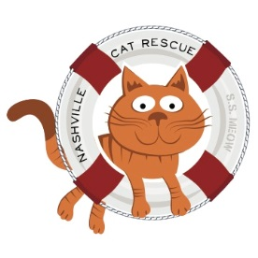

2020 Nashville Cat Rescue Projected Operating Budget

Expenses:
- Supplies purchased or reimbursed on behalf of adoption centers and for foster homes: $25,000
- Other veterinary supplies (purchased directly from manufacturer, including flea treatment and preventative, dewormer, combo test): $20,000
- Insurance: $1,250
- Bank Charges: $300
- Advertising and promotion: $3,000
- Miscellaneous (Adoption fees reimbursed to adopters that have returned cats): $2,000
- Professional Veterinary fees: $240,000
- Printing and postage: $1,500
- Occupancy, rent, utilities, accounting and maintenance: $15,500
Total: $308,550

Income:
- Adoption Fees: $100,100 - $110,500.
  - Based on 1,100 - 1,200 adoptions
  - We hope to do over 1,200 adoptions in 2020
- Contributions, gifts, grants, fundraising: $200,000 (Operational)
Total: $300,100-$310,500

615-596-4471
P.O. Box 140898
Nashville, TN 37214
nashvillecatrescue.org

