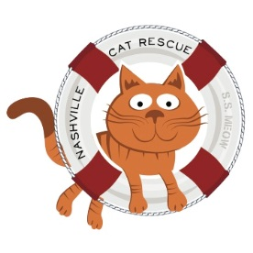

2019 Nashville Cat Rescue Projected Operating Budget

Expenses:
- Supplies purchased or reimbursed on behalf of adoption centers and for foster homes: $22,000
- Other veterinary supplies (purchased directly from manufacturer, including flea treatment and preventative, dewormer, combo test): $16,500
- Insurance: $973
- Bank Charges: $300
- Miscellaneous (Adoption fees reimbursed to adopters that have returned cats): -$1,000
- Professional Veterinary fees: $210,000
- Printing and postage: $4,500
- Occupancy, rent, utilities, accounting and maintenance: $4,500
Total: $259,773

Income:
- Adoption Fees: -$90,000 -100,000.
  - Based on 1,000 - 1,100 adoptions
  - We hope to do over 1,200 adoptions in 2019
- Contributions, gifts, grants, fundraising: $160,000 (Operational)
Total: $250,000-$260,000

615-596-4471
P.O. Box 140898
Nashville, TN 37214
nashvillecatrescue.org

