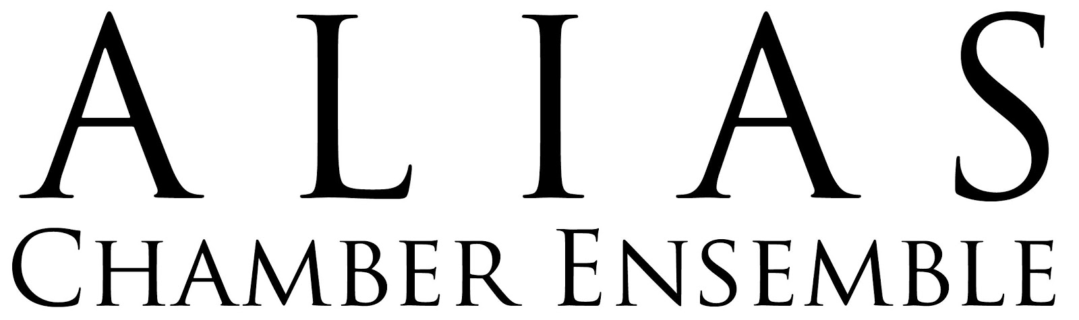

2021 Financial Statement

REVENUE
Program Revenue $920.00
Individual Public Support $9,691.37
Corporate Direct Support $2,775.00
Grants Income $26,669.00
CD Sales Income $210.00
Fundraiser Event Income $0.00
Other Income (Amazon Smile, etc.) $18.71
Cash Box Reimbursement $250.00

TOTAL Revenue $40,534.08

EXPENSES
Program Expenses
AIC Musician Compensation $6,900.00
Concert Refreshments & Expenses $748.18
Performance Material $55.94
Printing, Promotion, Mailing $1,261.79
Fundraiser Event Expenses $0.00
Other Performances Musician Compensation $0.00
Guest Artist Fees (incl travel) $0.00
Cash Box $250.00
TOTAL $9,215.91

Staffing and Consultants
Managing Director $10,000.00
Artistic Director $7,200.00
AIC Program Manager $4,600.00
Grant Writing $0.00
Accounting and Professional Fees $404.85
TOTAL $22,204.85

G&A Expenses
Office Supplies $581.19
Office Space Lease $650.00
Technical Supplies & Equipment $481.48
Online/Website Service Fees $268.97
Professional Memberships $195.95
Development Entertainment $1,164.97
Online Contributions Fee (PayPal, etc.) $172.99
Insurance/Licenses $1,657.94
TOTAL $5,173.49

TOTAL EXPENSES $36,594.25

TOTAL INCOME: $3,939.83

ACCOUNT BALANCES (as of 12/31/2021)

Checking $21,290.51
Money Market (Reserve) $28,944.24
PayPal $569.10
Stripe $277.15

TOTAL Cash on Hand $51,081.00

ALIAS ended 2021 with a surplus for the third consecutive year thanks to a combination of slightly reduced expenses (in Program and Staffing categories) and an increase in corporate giving. Additionally, individual donations and grant funding were both on par with most years while the overall cost of programming was still down due to the ongoing pandemic.
A surplus of just under four thousand dollars is certainly notable in the current arts ecosystem, it is significantly less than the seven- and twelve-thousand dollars of surplus from 2019 and 2020 respectively (although 2020 included the influx of one-time CARES Act grant funds). As we enter 2022 fully staffed with expectations for a full season of concerts and educational programming, we are planning to expand both our non-governmental grant sources as well as corporate sponsorships, while also developing additional revenue streams through audio and video recordings that can be released on a variety of platforms as singles (thereby avoiding the process and expenses of a fully-produced album).
ALIAS’s 2022 Proposed Budget expects $1,380 in surplus. This may not leave a lot of wiggle room (though it should be noted 2021 budgeted a surplus of only $475), but three years of significant surplus have allowed us to continue to grow our Reserve funds thereby ensuring our financial stability even if we run a deficit.

