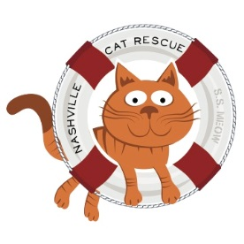

Nashville Cat Rescue Projected Operating Budget-2018

Expenses:
- Supplies from PetSmart for food /litter for foster homes-$15,000
- Reimbursement for food/litter purchases by fosters for NCR foster
cats-$6,000
- Other veterinary supplies-$13,000
- Insurance-$973
- Bank Charges-$300
- Miscellaneous-$1,000- Adoption fees reimbursed to adopters that have returned cats
- Professional Veterinary fees-$150,000
- Printing and postage-$4,000
- Occupancy, rent, utilities, accounting and maintenance- $4,223
Total: $194,496

Income:
- Adoption Fees-$90,000-100,000.
  - Based on 1,000-1,100 adoptions
  - We hope to do over 1,100 adoptions in 2018
- Contributions, gifts, grants, fundraising- $110,000 (Operational)
Total: $200,000-$210,000

615-596-4471
P.O. Box 140898
Nashville, TN 37214
nashvillecatrescue.org

