Leadership Team

TuneTown Show Chorus

June 6, 2021

On June 6, 2021 I met with Linda Resha in order to conduct an audit of the records for
TTSC for the period from May 1, 2020 to April 31, 2021.

I reviewed monthly bank statements (Main Account) for all 12 months. I matched up the bank deposits with the supporting documents attached. For checks and disbursements, I matched each entry on bank statement with proper disbursement request and support document. There were no irregularities.

With respect to the TTSC Shower account, I verified the deposits and the disbursements in the same manner as the Main Account.

Reconciliation reports provided were also verified as I did each month. Savings account statements were in order.
The deposits and disbursements where consistent with the financial records. The
records are maintained in folders monthly with bank statements and backup for each account. General accounting rules are being followed.

I have no recommendations for any changes at this point. Respectfully,
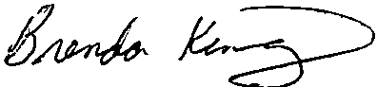

Brenda King

Office Manger

Jackson Hewitt Tax Service

