Jonathan Wilson, Head of School
2100B Nashville Pike
Gallatin, TN 37066

July 23, 2018

Dr. Jonathan Wilson, Head of School
2100B Nashville Pike
Gallatin, TN 37066

RE: Edison School (The)

Dear Jonathan Wilson:

Based on the information and materials submitted, Edison School (The) qualifies as an exempt educational institution as defined by Tenn. Code Ann. § 48-101-502 (b). As such, this organization currently has no duty to register with this division.

If you have any questions, please contact us at (615) 741-2555.

Sincerely,
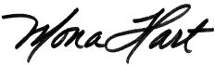
Mona Hart
Director

