Tennessee Secretary of State Tre Hargett
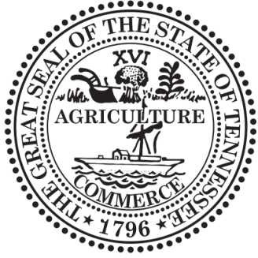
Division of Business and Charitable Organizations 312 Rosa L. Parks Avenue, 6th Floor Nashville, Tennessee 37243-1102
August 07, 2023

Mrs. LISA WOOLEY
108 7TH AVENUE SOUTH NASHVILLE, TN 37203

RE: Registration to Solicit Funds for Charitable Purposes Organization Name: ROOFTOP FOUNDATION CO Number: CO8427
Renewal Date: 06/30/2024
Dear Mrs. LISA WOOLEY :
Pursuant to the Tennessee Charitable Solicitations Act, T.C.A. § 48-101-501,et seq. the Tennessee Secretary of State has reviewed your application and is pleased to announce your organization's registration to solicit contributions has been approved.
The organization must maintain statutory compliance by submitting a renewal application and required fees on an annual basis. At that time you may be required to submit tax filings, financial statements, proof of IRS status, and other documents related to your organization and its fundraising activities. You can find additional information and submit additional filings online at https://sos.tn.gov/charities. The "CO" Number listed above will serve as your organization's charitable registration number and should be used when submitting any charitable filings or correspondence.
Please also be advised that if the organization's application or other provided information includes false, misleading or deceptive statements, appropriate action will be taken. Pursuant to the Tennessee Charitable Solicitations Act, a civil penalty of up to five thousand dollars ($5,000.00) may be assessed for any violation.
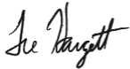
Thank you for registering your organization and please do not hesitate to contact us with any questions. Sincerely,

Tre Hargett Secretary of State

