WOUNDED WARRIOR PROJECT ORGANIZATIONAL BUDGET FOR FY 2022

Program Budget | FY 2022
Connection Programs | $44,632,775
Mental Health and Wellness Programs | $77,867,136
Physical Health and Wellness Programs | $11,309,930
Financial Wellness Programs | $28,696,293
Independence Program | $29,193,550
Government Relations and Partnerships | $22,026,251
Resource Development | $98,085,885
Administrative Spend | $32,712,636
Total Expenses | $344,524,456

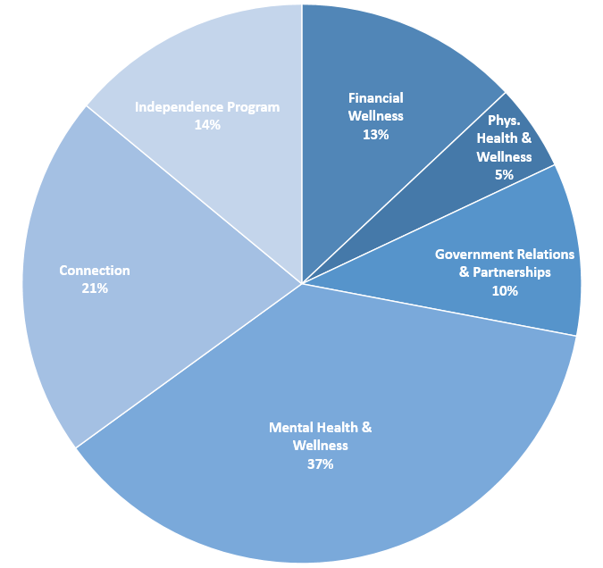

WWP Program Spend Breakout for FY2022:
Financial Wellness 13%
Physical Health and Wellness 5%
Government Relations and Partnerships 10%
Mental Health and Wellness Programs 37%
Connection Programs 21%
Independence Program 14%

