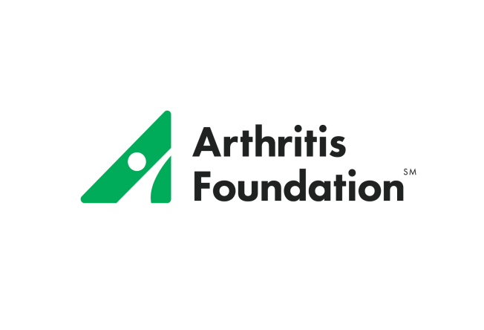
Arthritis Foundation, Inc.

Fiscal Year, 2017

One Entity Budget
($000) in thousands
2017 Board –Approved Budget
INCOME

Direct Response Marketing Contributions $ 9,620
Corporate Contributions $12,804
Foundations $ 2,224
Personal Contributions $ 3,517
Other Direct Contributions $ 590
Special Events – adjusted gross $21,463
Bequests/Planned Giving $13,500
Indirect Public Support $ 1,003
Government Grants $ 150
Investment and Royalty Income $ 3,881
Sales and Services Fees $ 3,246
Advertising Income $ 6,100
All Other Income $ 200

Total Operating Revenue $78,297

EXPENSES
Research $10,000
Salaries, Payroll Taxes & Benefits $36,463
Professional Fees $ 7,239
Arthritis Today Commissions & Fulfillment $ 865
Supplies $ 475
Printing, Publications, Artwork $ 2,763
Direct Marketing Expense $ 8,250
Postage, Shipping, & Delivery $ 2,683
Telephone $ 730
Occupancy $ 3,555
Staff & Volunteer Travel $ 2,272
Meetings and Conferences $ 2,755
Equipment Lease & Maintenance $ 1,090
Advertising $ 193
Depreciation & Amortization $ 1,160
All Other Expenses $ 3,650

Total Operating Expenses $84,142

NET INCOME (LOSS) $(5,845)

