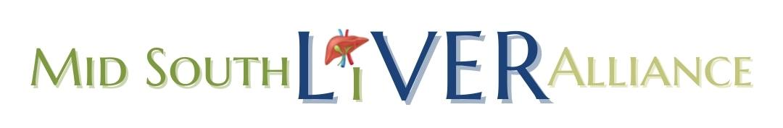
Financial Statement
Budget vs. January 2023 – June 2023

Chart of Accounts | 2023 Budget | 2023 Actual - June
Income
Cash beg month (equity) |  | $ 5,724.30
Individual Donations | $ 3,622.00 | $ 2,242.00
Grant income | $ 3,500.00 | $ 1,000.00
Corporate Donations | $ 30,000.00 | $ 18,317.42
Walk Income | $ 20,000.00 | $ 1,000.00
Pickleball Income | $ 2,500.00 | $ 1,250.00
Interest Income | $ 3.00 | $ 2.49
Total Income | $ 59,625.00 | $ 29,536.21
Expenses
Payroll | $ 7,959.08 | $ 979.54
Taxes AP ( 941, tax fees paid Jan 21) | $ 5,467.80 | $ 2,733.85
Office Expenses – Printer paper, etc | $ 1,309.12 | $ 635.14
Setup/Licensing fees – TN | $ 20.00 | $ 20.00
CC Fees | $ 273.07 | $ 336.68
Bank Fees | $ 75.46 | $ 60.71
Board Expenses | $ 200.00 | $ -
Postage/Shipping | $ 180.00 | $ 97.00
Website | $ 531.57 | $ 131.57
Walk expenses | $ 4,000.00 | $ 6.30
Pickleball Expenses | $ 600.00 | $ 463.98
Phone | $ 1,550.00 | $ 769.23
Program Cost | $ 15,000.00 | $ 5,945.89
Memberships (CNM) (Costco) | $ 250.00
Accreditation Fees | $ 3,000.00 | $ 1,000.00
Professional Fees - Acct | $ 2,500.00
Printing | $ 2,000.00 | $ 552.07
TOTAL EXPENSES | $ 44,916.10 | $ 13,731.96
Net INCOME | $ 14,708.90 | $ 15,804.25

