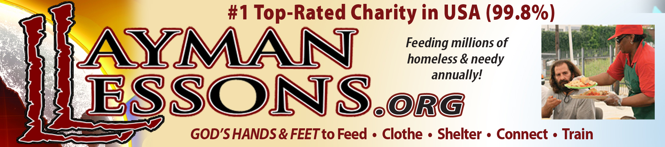

Layman Lessons Church and Welcome Baptist Church
Budget Fiscal Year Ending December 31, 2022

DONATIONS
Cash
Non-designated $ 150,000.00
Proposed Grants 70,000.00

Gifts in Kind
Food and Drinks 10,000,000.00
Clothing 150,000.00
Freight Reimbursed 48,000.00

TOTAL DONATIONS $10,418,000.00

DISTRIBUTIONS
Donations to the Homeless and Needy
Food and Drinks $10,000,000.00
Clothing 150,000.00
Proposed Grant Funded Projects
Four Season Tents (500) 25,000.00
Sleeping bags (500) 15,000.00
Used Refrigerated Box Truck 30,000.00

Program Expenses
Salaries/wages/commissions (none since 2001) 0.00
Compensation – Benefits (none since 2001) 0.00
Tithe Barn - Operations, Repairs, Maintenance 15,000.00
Equipment - Purchases, Repairs, Maintenance 5,000.00
Cartage - Local transport/deliveries 7,500.00
Freight - Donated food/drinks shipping costs 115,000.00
Food purchased for the homeless 3,000.00
Water purchased for the homeless 1,200.00
Computer/Internet Services and Website Services 5,300.00
Utilities – Church offices, Nashville, Murfreesboro 2,000.00
Utilities – Tithe Barn, Madison 700.00

DISTRIBUTIONS (Cont’d)

Vehicles – Fuel, Repairs, Maintenance 10,000.00
Professional Services – Graphic Arts 2,500.00
Professional Services – Website Administration 465.00
Professional Services - Video 1,500.00
Insurance – Vehicles (GEICO) 1,100.00
Insurance - Property & liability (Church Mutual) 3,100.00
- Fleet (Church Mutual) 2,200.00
Office Supplies, Printers, Equipment 1,200.00
Postage 150.00
Printing 2,000.00
Signs 1,000.00
Legal 1,500.00
Accounting 1,500.00
Corporate – State filings 350.00
Mobile Shower/Laundry 3,000.00
Supplies for homeless 2,000.00
Grants – Research Subscription 199.00
Women’s Training Center 500.00
Phone 700.00
Discipleship/Volunteer Training Programs
- Layman Lessons Education Programs 500.00
Contingencies 5,000.00

TOTAL DISTRIBUTIONS $10,415,164.00

Karen L. Johnston
Executive Director

