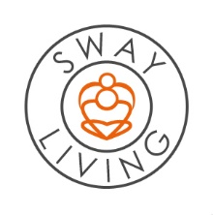

Proposed 2021 Annual Operating Budget

National Alliance of Pan African Seminarians

CATEGORY | AMOUNT BUDGETED
Salaries | 0
Professional Fees | 0
Supplies | 7286
Telephone | 2400
Postage/Shipping | 500
Occupancy | 12252
Printing/Publications | 2000
Travel/Conferences &Meetings | 2584
Other Non-Personnel | 2978
TOTALS | 30000

