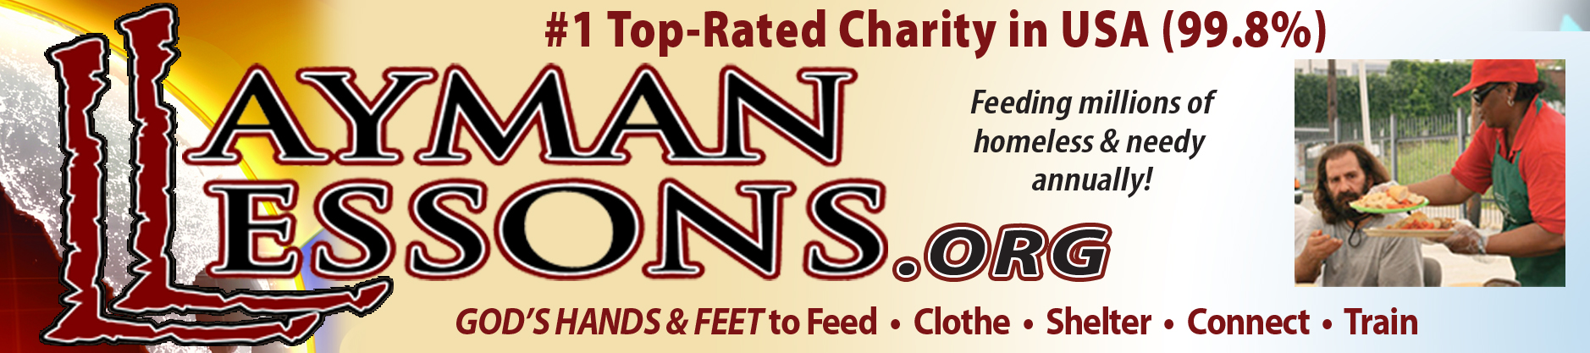

Layman Lessons Church and Welcome Baptist Church
Budget Fiscal Year Ending December 31, 2023

DONATIONS
Cash
Non-designated $ 95,000.00
Designated – tents, sleeping bags 5,000.00

Gifts in Kind
Food and Drinks 7,500,000.00
Clothing 200,000.00
Freight Reimbursed 8,400.00

TOTAL DONATIONS $7,808,400.00

DISTRIBUTIONS
Donations to the Homeless and Needy
Food and Drinks $7,500,000.00
Clothing 200,000.00
Proposed Designated Donation Projects
Four Season Tents and Sleeping bags 5,000.00

Program Expenses
Salaries/wages/commissions (none since 2001) 0.00
Compensation – Benefits (none since 2001) 0.00
Tithe Barn - Operations, Repairs, Maintenance 15,000.00
Equipment - Purchases, Repairs, Maintenance 15,000.00
Freight - Donated food/drinks shipping costs 25,200.00

Water purchased for the homeless 1,200.00
Computer/Internet Services 1,500.00
Utilities – Tithe Barn, Madison 1,200.00

DISTRIBUTIONS (Cont’d)

Vehicles – Fuel, Repairs, Maintenance 10,000.00
Professional Services – Graphic Arts 1,500.00
Professional Services – Website Administration 3,600.00
Insurance – Vehicles (GEICO) 1,300.00
Insurance - Property & liability (Church Mutual) 3,400.00
- Fleet (Church Mutual) 2,400.00
Office Supplies, Printers, Equipment 1,200.00
Postage 150.00
Printing 2,000.00
Signs 1,000.00
Legal 1,500.00
Accounting 1,500.00
Corporate – State filings 350.00
Mobile Shower/Laundry 3,000.00
Grants – Research Subscription 200.00
Phone 700.00
Discipleship/Volunteer Training Programs
- Layman Lessons Education Programs 500.00
Contingencies 10,000.00

TOTAL DISTRIBUTIONS $7,808,400.00

Karen L. Johnston
Executive Director

